Neti pot:  Research has shown that nasal irrigation helps relieve sinus congestion.  Neti pots are available over-the-counter at many drug stores, health food stores, and online retailers. They usually cost between $10 and $20.  Disclaimer: this information is a general suggestion, and does not diagnose, nor guarantee that you will find relief from sinusitis. Please contact your Naturopathic doctor or primary health care provider for further care.  References:  Gaby, A. (2011) Nutritional Medicine. Fitz Perlberg publishing, pp.977.  http://www.webmd.com/allergies/sinus-pain-pressure-11/neti-pots.  http://www.whfoods.com/genpage.php?tname=nutrient&dbid=106  www.acupressure.com  Pizzorno and Murray. (2005) Textbook of Natural Medicine. Elsevier. Pp 1545. |  |  | As shown on the lower left bottom-corner of this page. Press the shown points with your thumb to a tolerable level. The first point (B2) is located at the inner corner of your eyebrow within the grove. Press up into the central ridge of your nose. The second point (LI20), is located in the grove, next to your nares. Press up and out, towards your ears. The third point (ST3) is located just medial to the second point. Press up and out towards your ears. This will help to gently drain your sinuses. |  | Sinusitis  - Home Remedies for Sinusitis  Dr Schmittat, ND, Lac, Dipl Ac  drschmittat.net  434-879-1332
Acupressure points
Home remedies  Diet and Nutrition:  - Limit intake of refined sugars and carbohydrates. They suppress aspects of the immune system.  - Vitamin C enhances your immune function, is anti-inflammatory, antiviral, and anti-allergic. Vitamin C rich foods include:  (highest Vitamin C content to lowest)  - Bell peppers  - Broccoli  - Brussel sprouts  - Strawberries  - Pineapples  - Oranges  - Kiwifruit  - Cantaloupe  - Cauliflower | What is Sinusitis?  Sinusitis is an inflammation or swelling of the lining of the sinuses. It is caused when the sinuses become blocked and filled with fluid. This blockage can often come from a common cold, allergies, nasal polyps, shift in the nasal cavity, cigarette smoking, swimming, diving, food sensitivities, or as a complication of other underlying conditions. Symptoms include nasal congestion, postnasal drip, headache, facial fullness, dental pain, fatigue, loss of smell, along with many other signs.  - Increase fluid intake to help drain the sinuses.  - Avoid foods that you may be sensitive to.  - Avoid Dairy, it is a common trigger.  - Avoid stimulants: when you have a sinus infection, they can dampen your immune system.  - Vitamin E: play a large role in immune function and enhances the lining of your sinuses. Foods rich in Vit E include:  - Sunflower seeds, Almonds, Spinach, Swiss chard, Avocado, Turnip greens, Asparagus, Beet greens, Mustard greens.  - Vitamin A: Also helps with immune function. Vit A rich foods: Sweet potato, carrots, spinach, kale, mustard greens, collard greens, turnip greens. | 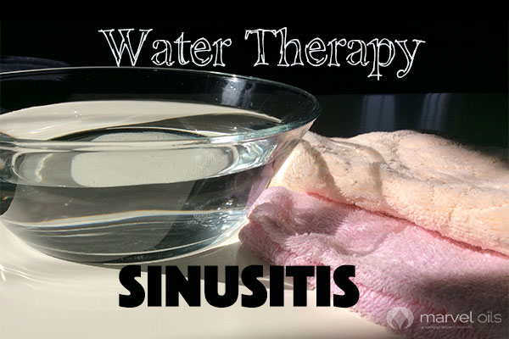 | Steam Inhalation:  Boil a large pot of water. Place your face about 1 foot over the bowl. Drape a towel over your head and around the bowl. Breathe the soothing steam for 1-5 min. You may add essential oils such as tea tree, lavender, eucalyptus, peppermint, and rosemary.  Hot and Cold compresses:  Hot and cold application increases the circulation, and helps reduce sinus swelling. Prepare two small facial towels, one bowl of warm water, and one bowl of cold water. Soak a facial towel in warm water, squeeze out most of the water, and place it over your forehead, cheeks, and nose. Leave it on for 3 min. Then soak the other small towel in the cold water, squeeze out most of the water, and place over forehead, cheeks, and nose for 1 min. Repeat hot and cold three times.

